INDEX

|  |  |  |
| --- | --- | --- |
| **S. No.** | **Title** | **Page No.** |
|  | Input a welcome message and display it |  |
|  | Input 2 numbers and display the largest & smallest number |  |
|  | Input 3 numbers and display the largest & smallest number |  |
|  | $1+x^{2}+x^{3} …+x^{n}$ $x-\frac{x^{2}}{2!}+\frac{x^{3}}{3!}-\frac{x^{4}}{4!} …±\frac{x^{n}}{n!}$ |  |
|  | Check if number is Perfect, Armstrong or Palindrome |  |
|  | Prime or composite |  |
|  | Fibonacci Series |  |
|  | Patterns |  |
|  | Character type |  |
|  | Convert marks to grade |  |
|  | Table of 10 |  |
|  | Check if date is valid |  |
|  | Factorial & Sum of the digits of a number |  |
|  | Find sum & average of odd, even and prime numbers |  |
|  | Sum of prime numbers in a range of 2 numbers |  |
|  | Calculate roots of quadratic equation |  |

Program 1

Aim: Write a python program to input a welcome message and display it.

Modules used: N/A

Data types used: String

Script:

Output:

Program 2

Aim: Write a python program to input 2 numbers and display the largest & smallest number.

Modules used: N/A

Data types used: String, float

Script:

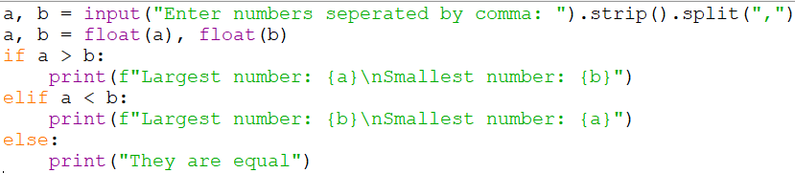

Output:

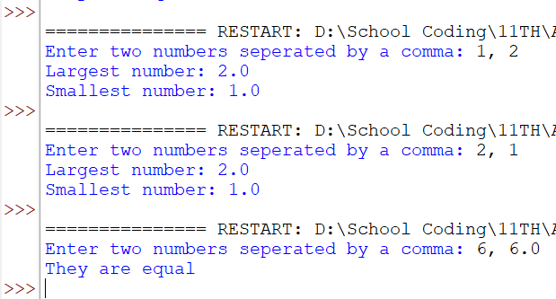

Program 3

Aim: Write a python program to input 3 numbers and display the largest & smallest number.

Modules used: N/A

Data types used: String, float

Script:

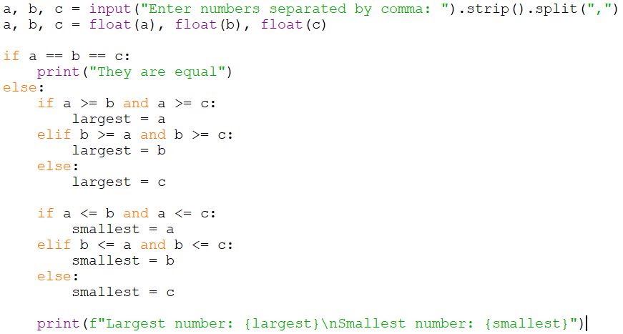

Output:

Program 4

Aim: Find the sum of the series:

Modules used: N/A

Data types used: Integer

Script:

Output:

Program 4

Aim: Find the sum of the series:

Modules used: N/A

Data types used: Integer

Script:

Output:

Program 5

Aim: A menu driven program that checks if the given number is perfect / Armstrong / Palindrome

Modules used: N/A

Data types used: Integer

Script:

Output:

Program 6

Aim: Write a program to input a number and check if the number is a prime or composite number.

Modules used: math

Data types used: Integer

Script:

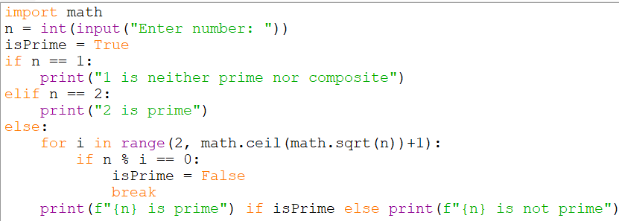

Output:

Program 7

Aim: Write a program to display the n terms of a Fibonacci series.

Modules used: N/A

Data types used: Integer

Script:

Output:

Program 8

Aim: Generate the following patterns using for loop

Modules used: N/A

Data types used: Integer / String

Script:

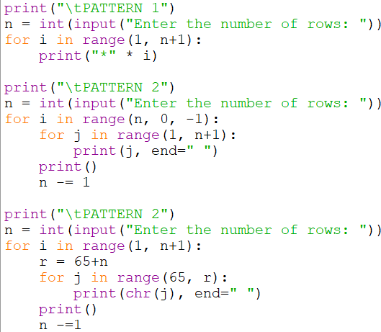

Output:

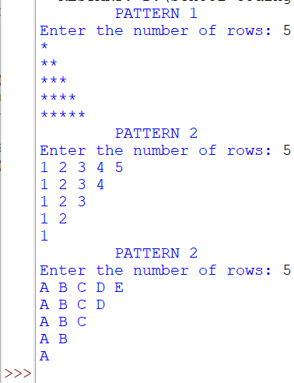

Program 9

Aim: Write a program to input a character and print whether it is an upper-case alphabet, lower-case alphabet, a digit, or special character

Modules used: N/A

Data types used: String

Script:

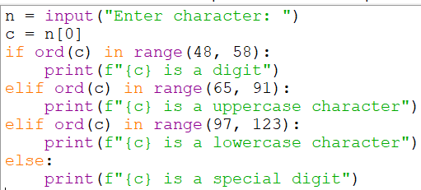

Output:

Program 10

Aim: To write a program to input percentage marks of a student and find the grade as per mark.

Modules used: N/A

Data types used: Integer

Script:

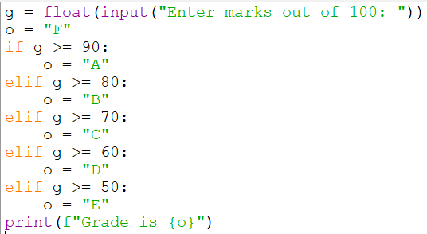

Output:

Program 11

Aim: Write a program to print the table of ten

Modules used: N/A

Data types used: Integer, String

Script:

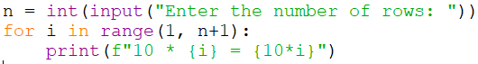

Output:

Program 12

Aim: Write a program to check validity of date

Modules used: N/A

Data types used: Integer

Script:

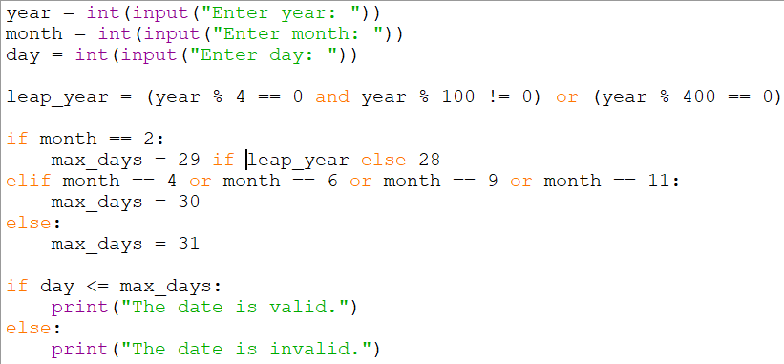

Output:

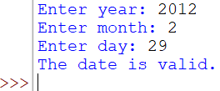

Program 13

Aim: Write a menu driven program to find a) factorial of a number b) Sum of digits of a number

Modules used: N/A

Data types used: Integer / String

Script:

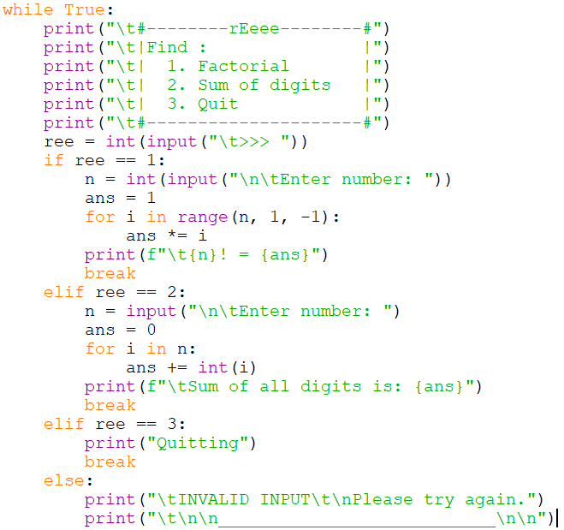

Output:

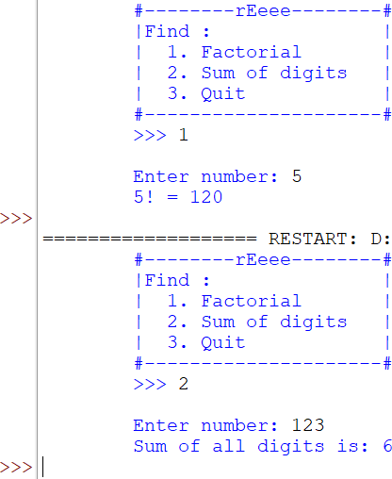

Program 14

Aim: Write a program to calculate sum and average of odd, even and prime no.

Modules used: N/A

Data types used: Integer / Float

Script:

Output:

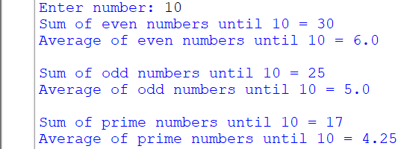

Program 15

Aim: Write a program to find sum of prime no. between 2 ranges

Modules used: N/A

Data types used: Integer / Float

Script:

Output:

Program 16

Aim: Write a program to calculate the roots of a quadratic equation

Modules used: math

Data types used: Integer / Float

Script:

Output:

Program 17

Aim: Write a program to input a sentence and count the number of times ‘a’ appears

Modules used: N/A

Data types used: String

Script:

Output:



Program 18

Aim: Write a program to take in a string and print out the following patterns

|  |  |  |  |  |
| --- | --- | --- | --- | --- |
| a | a | abc | cba | a |
| bb | ab | ab | cb | abab |
| ccc | abc | a | c | abcabcabc |

Modules used: N/A

Data types used:

Script:

Output:

Program 19

Aim: Write a program to input a sentence and count the number of words

Modules used: N/A

Data types used: String

Script:

Output:



Program 20

Aim: Write a program to input a word and count the number of vowels in the word

Modules used: N/A

Data types used: String

Script:

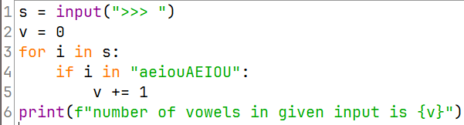

Output:

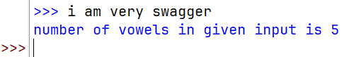

Program 21

Aim: Write a program to input a word and check if it is a palindrome

Modules used: N/A

Data types used: String

Script:

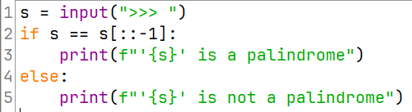

Output:

Program 21

Aim: Write a program to input a word and a sentence and check weather the word is present in sentence

Modules used: N/A

Data types used: String

Script:

Output:

